EXPERIMENT 5 A

DATA VISUALIZATION USING MATPLOTLIB

Aim
To create and analyze various data visualizations such as Line Charts, Bar Charts, Pie Charts, Histograms, Scatter Plots, and Box Plots using Matplotlib for effective data interpretation.

Sample Dataset

Diabetes Patient Dataset
ID | Age | Gender | Glucose | BMI | HbA1c
101 | 25 | Female | 110 | 22.5 | 5.4
102 | 45 | Male | 145 | 27.8 | 6.5
103 | 52 | Female | 160 | 30.2 | 7.2
104 | 38 | Male | 130 | 25.4 | 6.0
105 | 60 | Female | 180 | 32.1 | 8.0
106 | 48 | Male | 155 | 29.5 | 7.0

Algorithm 1 – Line Chart
Step 1 - Import Matplotlib.
Step 2 - Create dataset.
Step 3 - Use plot() function.
Step 4 - Add title and labels.
Step 5 - Display chart.

Program 1

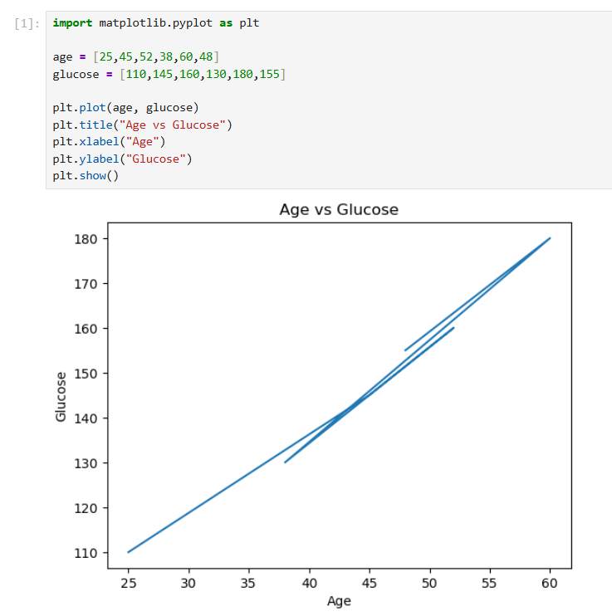

Algorithm 2 – Bar Chart
Step 1 - Create dataset.
Step 2 - Use bar() function.
Step 3 - Add chart labels.
Step 4 - Display chart.

Program 2
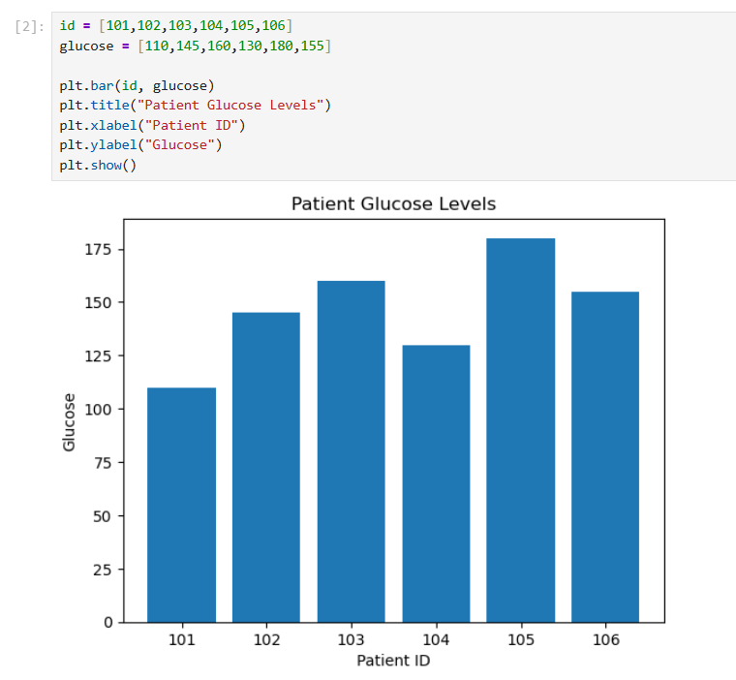

Algorithm 3 – Pie Chart
Step 1 - Create category data.
Step 2 - Apply pie() function.
Step 3 - Add percentage labels.
Step 4 - Display chart.

Program 3

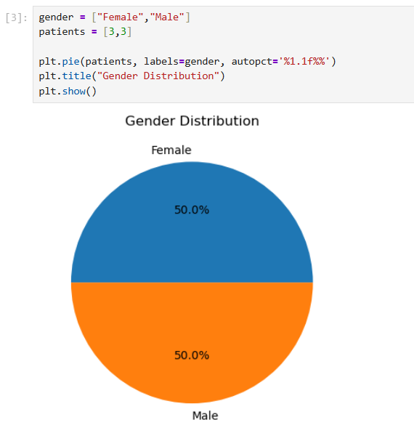

Algorithm 4 – Histogram
Step 1 - Create numerical data.
Step 2 - Use hist() function.
Step 3 - Add chart labels.
Step 4 - Display chart.

Program 4
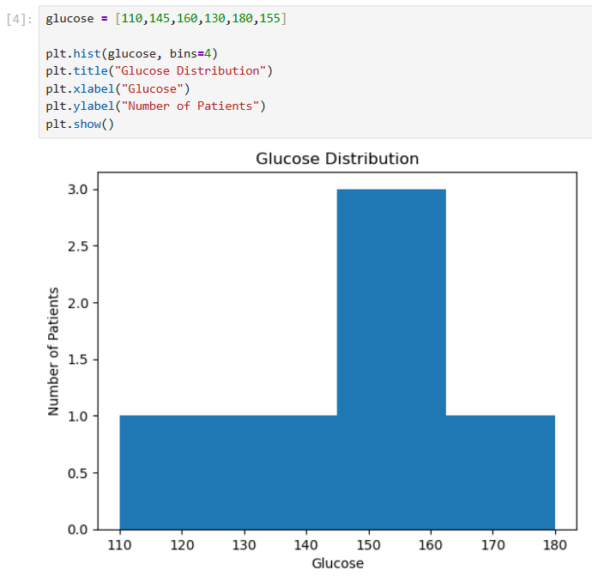

Algorithm 5 – Scatter Plot
Step 1 - Create two numerical datasets.
Step 2 - Use scatter() function.
Step 3 - Add title and labels.
Step 4 - Display chart.

Program 5
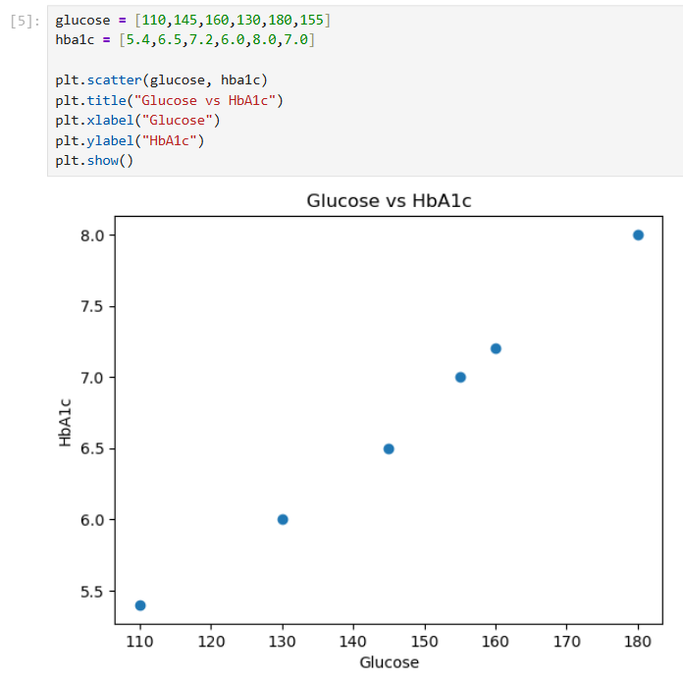

Algorithm 6 – Box Plot
Step 1 - Create numerical dataset.
Step 2 - Use boxplot() function.
Step 3 - Add title and labels.
Step 4 - Display chart.

Program 6
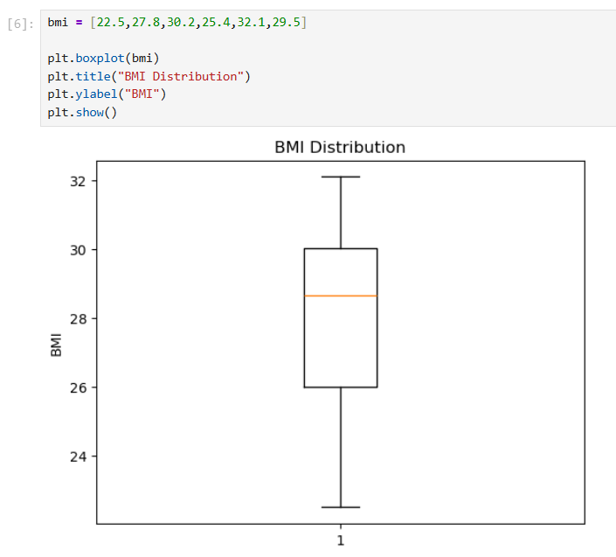
Algorithm 7 – Multiple Line Charts
Step 1 - Create two datasets.
Step 2 - Plot both datasets.
Step 3 - Add legend.
Step 4 - Display chart.

Program 7

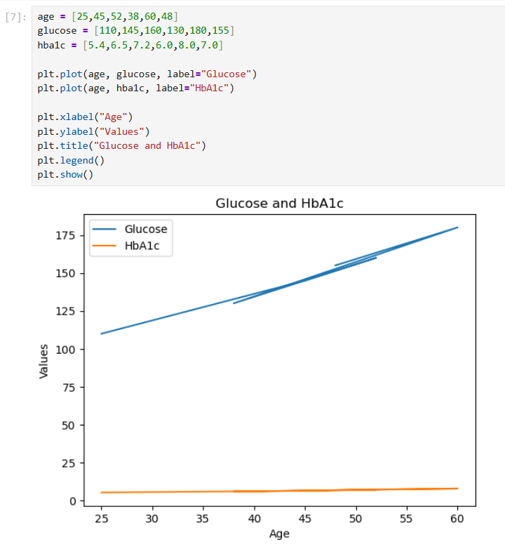

Result
Thus, various data visualizations including Line Chart, Bar Chart, Pie Chart, Histogram, Scatter Plot, and Box Plot were successfully created and analyzed using Python and Matplotlib on the diabetes patient dataset.

